[E119] Front panel

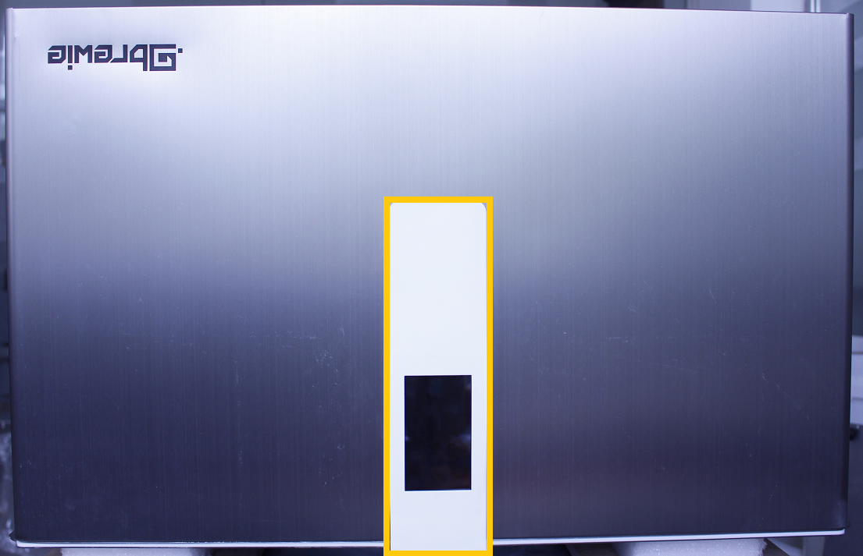

To remove the front panel stretch back the inner fastening clamp while pulling it down.

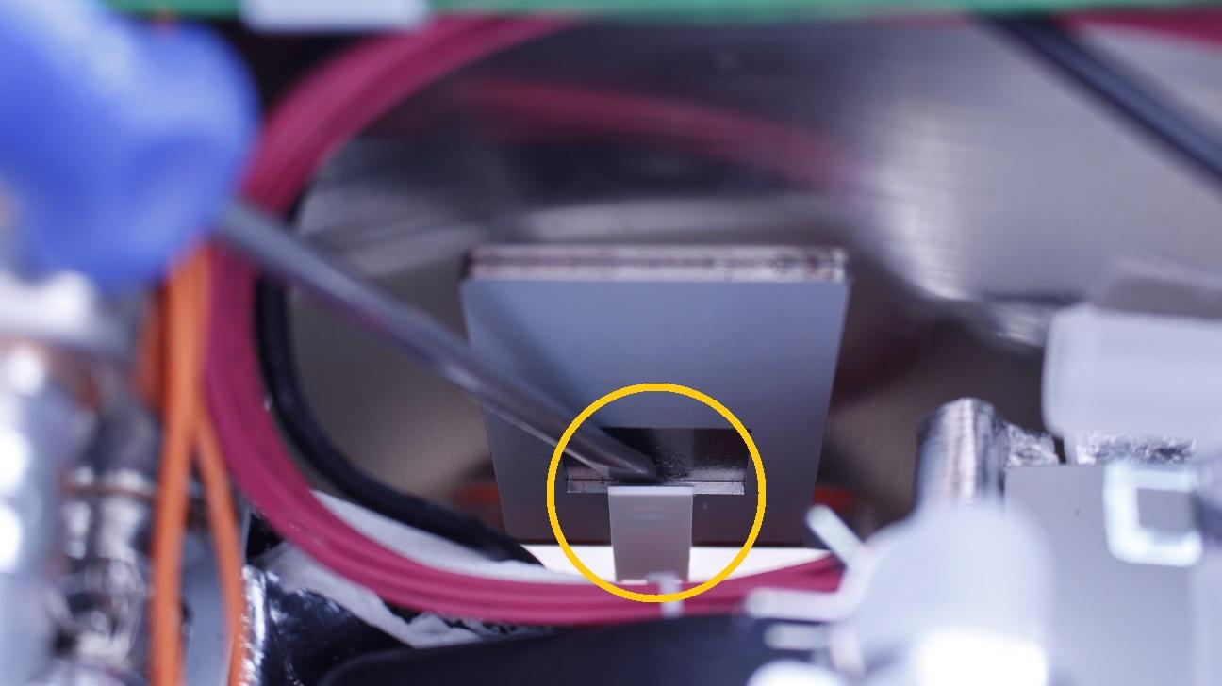

The panel should pop out from its place.

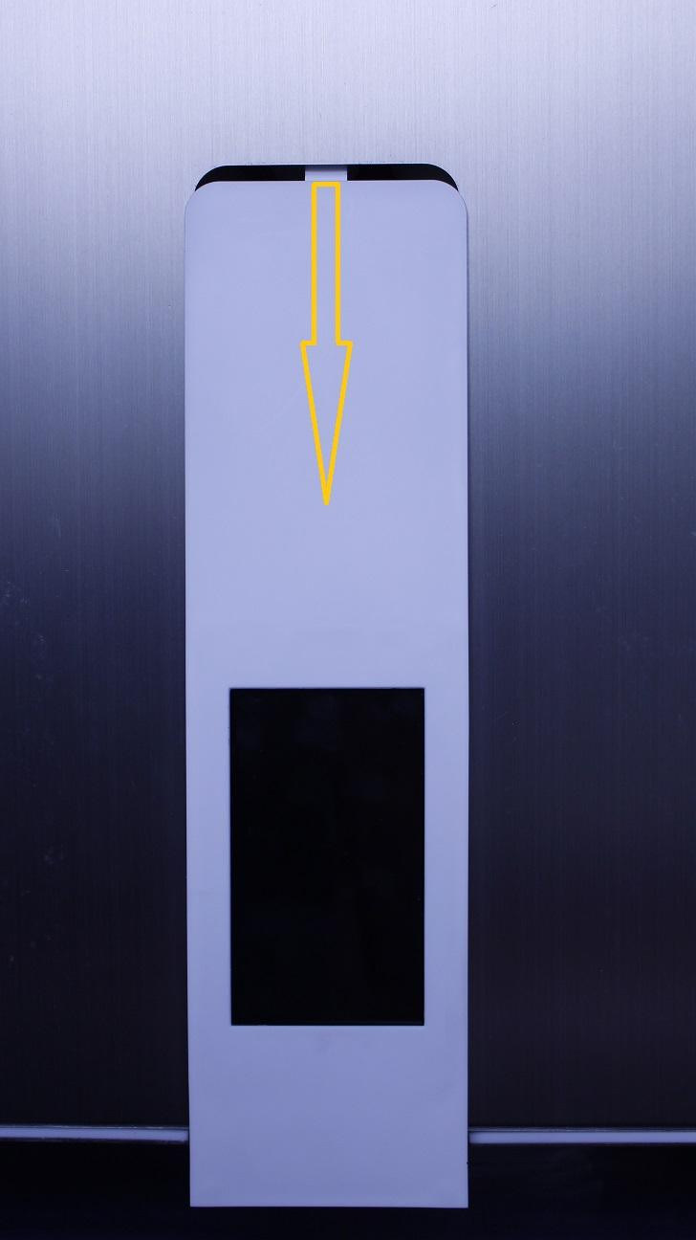

Disconnect the plugs and remove the panel.

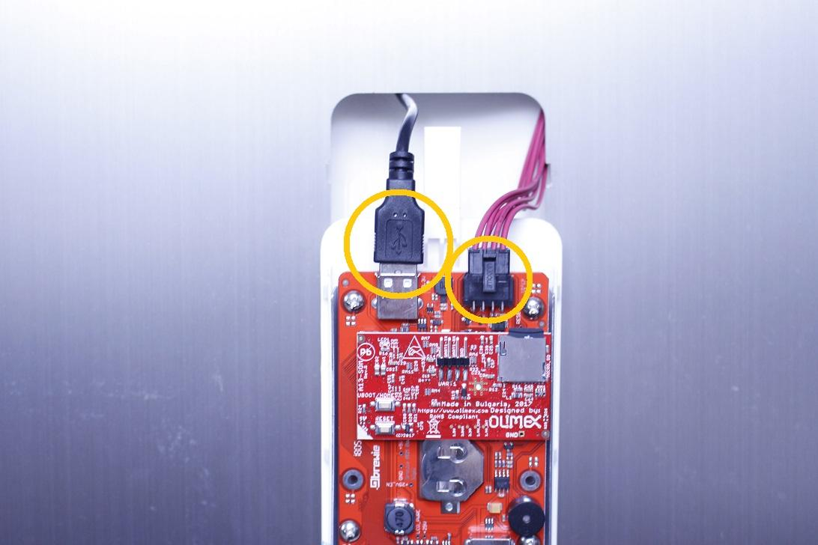

Parts of the front panel:

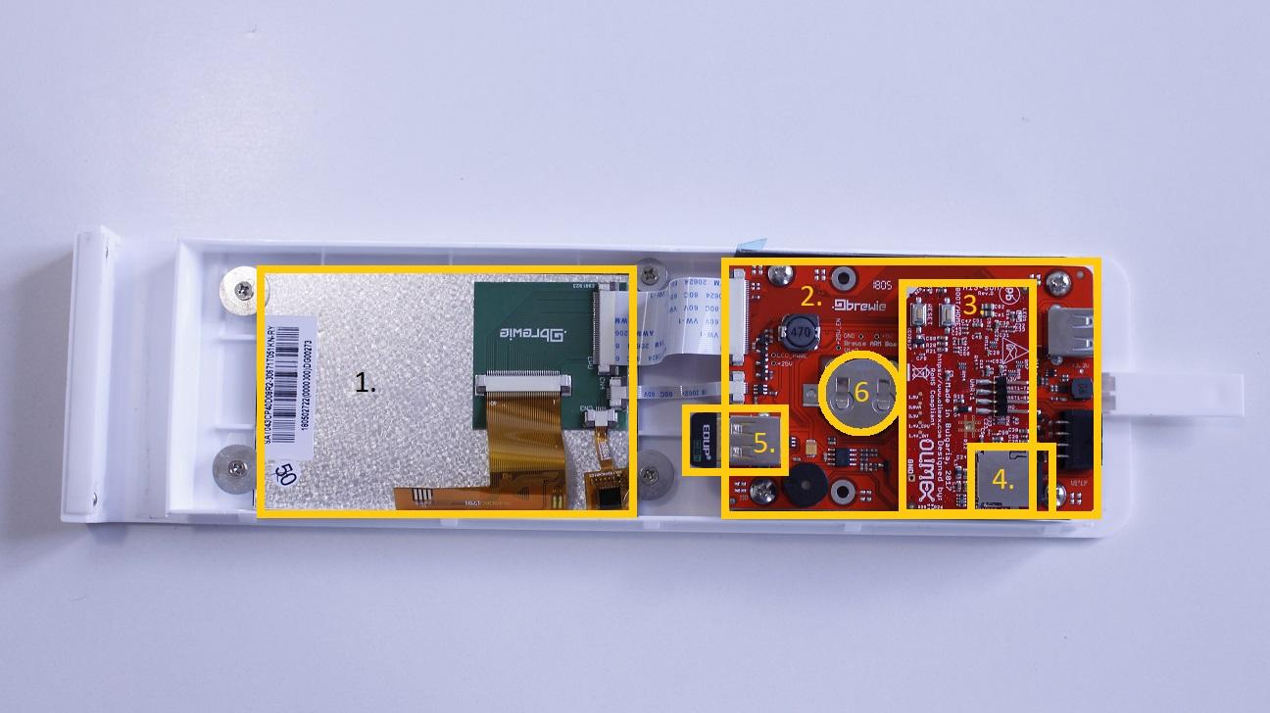

1. Display
2. ARM panel
3. Olimex panel
4. SD card
5. WIFI stick
6. Battery

Reassemble consists of the same steps in reverse.

IMPORTANT: In case the front panel doesn’t pop in the cover easily, don’t force it, gently push the cover over it.

